Chapter 6, Solution 58.

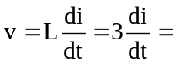3 x slope of i(t).

Thus v is sketched below:
v(t) (V)
-6
2
3
4
1
5
7
6
t (s)
6

